ComplainEase – Complaint Management
Project: ComplainEase | Technology: HTML, CSS, JavaScript (localStorage)

Aim
To build a complaint management system where citizens file complaints with location and proof, officers resolve them, and admin supervises.

Algorithm
- Start: load users, complaints and FAQs.
- User registers/logs in and files a complaint (with location and proof).
- Complaint is assigned to an officer.
- Officer updates status, adds proof/info; user gives feedback.
- Admin approves officers, creates accounts, manages FAQs and users.
- Dashboards show complaint counts by status.
- Save to localStorage. Stop.

Result
The ComplainEase – Complaint Management was implemented successfully using HTML, CSS and JavaScript. All modules (login, role-based pages, data entry, search/booking and admin management) work correctly in the browser, and data persists using localStorage.

Implementation (Output Screenshots)
Home page
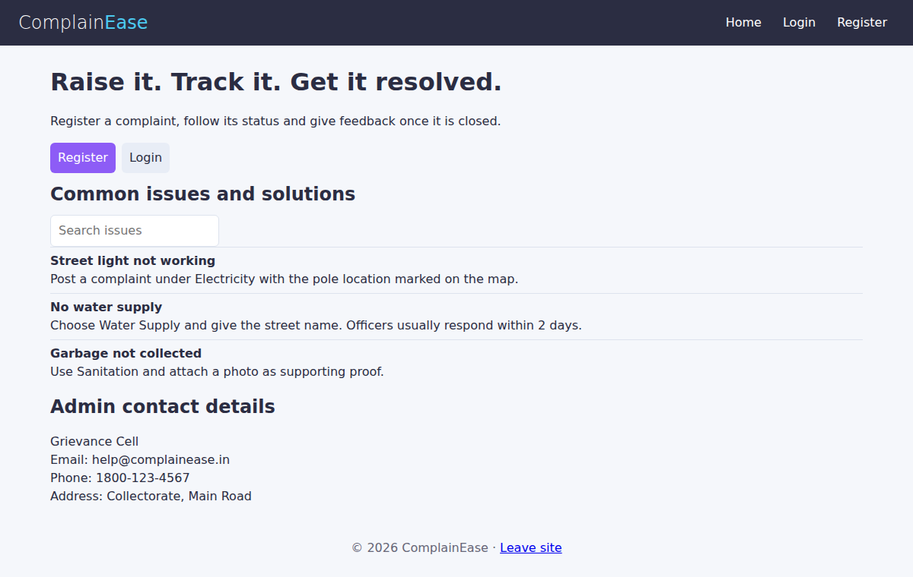
After login (admin / dashboard)
